**ARC 5238 Insufficient Material Check**

The 5238 Insufficient Material Check project is for checking if there is enough material for backflushing to claim pieces on a job. It can be installed through the ARC one click install. When checking for adequate material, the program will look at the bin with the same name as the work center.

When backlashing is required on a sequence, the user will be prompted when entering the update screen on the GUI.

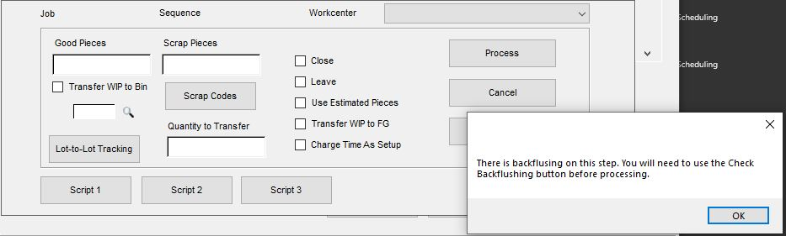

After clicking ok, the process button will be locked until the script 2 button (Check Backflushing) is used.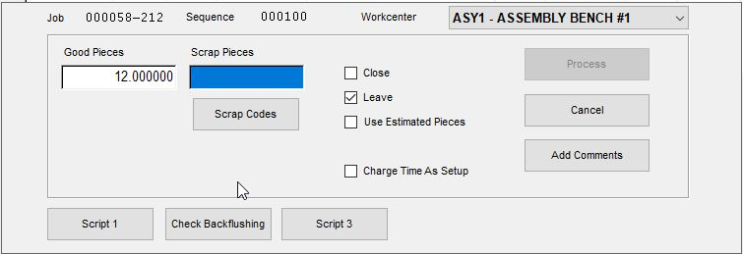

When this is clicked, the program will check the job being updated and get the total required material for claiming how ever many pieces are entered. It will also look at jobs that have already had pieces claimed but have not been processed by Online Update yet.

If there is not enough material, the user will be notified, and the process button will not be unlocked.

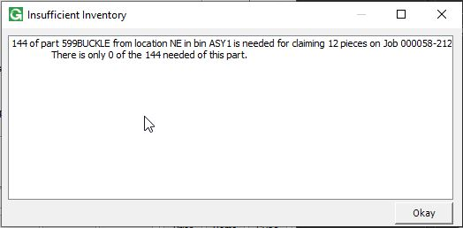

If there is enough material, the user will be notified and the process button will be unlocked.

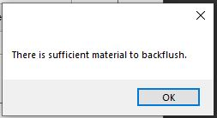

The program works the same way on the multiple job update screen, except it checks the total material required for all jobs being updated.

